Don’t you think it’s about time we got together?! Perry and Michelle would like to establish the first yearly Darys and Clella family reunion. Perry and Kodi are sponsoring this year’s reunion at their mountain property located in Placerville, 40 miles north of Boise, Idaho. The reunion is scheduled for the weekend of July 17th and 18th. The outing will be a mountain retreat camp-out. Bring your camper, tent, or RV. Also, there are local area motel accommodations listed with the directional map on the back, or you can stay in Boise just an hour away from Placerville.

A family BBQ is scheduled for Saturday evening. Hamburgers will be provided. Please bring a side dish and your favorite beverage. We plan on music, games, and lots of fun. There are numerous mountain trails and streams for fishing, mountain biking, four wheeling, and dirt bike riding.

You can view the local area by logging on to Perry and Kodi’s web site at. www.ekkercabin.com

Please RSVP Perry or Michelle by June 1st at the addresses below.

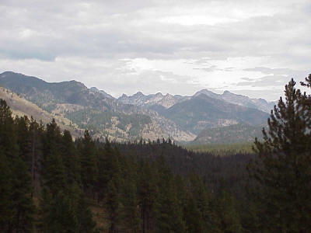 | Michelle Miller  PO Box 51  Aberdeen, ID 83201  (208) 397-3146  Millerm51570@yahoo.com  Perry Ekker  4244 N. Liesel Ln.  Boise, ID 83704  (208) 376-0621  perryekker@homeinternet.net

