Perry and Kodi’s 10th Wedding Anniversary Party
Saturday, June 23rd, 2012
At the EKKER CABIN in Placerville, Idaho
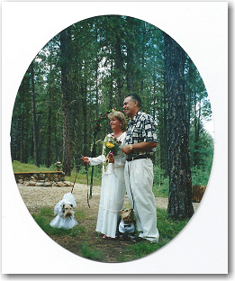 | Come join the fun with live Americana Music from Hecktor Pecktor  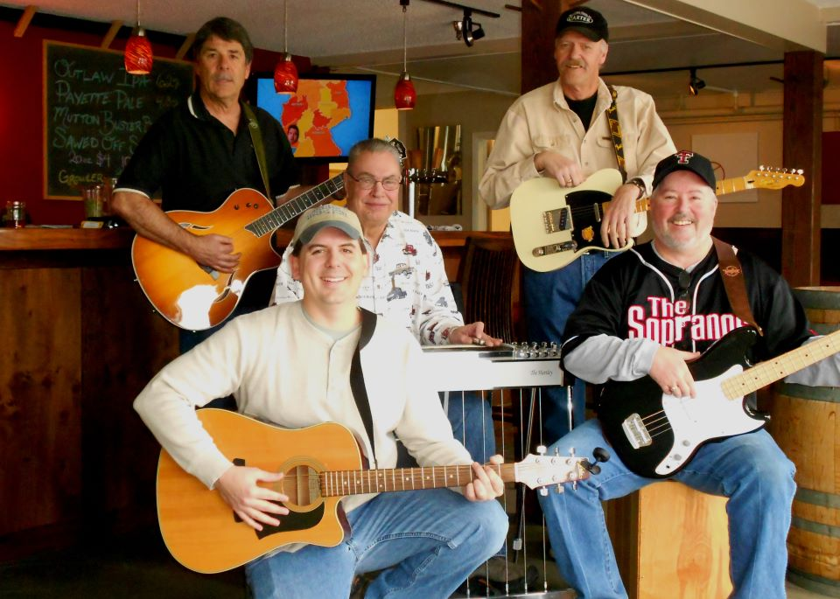  From left to right - Karl Peck, Brian Peck, Perry Ekker, Larry Miller, and Doug Grant.
June 22nd, 2002 – Placerville, Idaho

PLEASE - RSVP by June 8^{th.}
E-mail ekkercabin@cableone.net or call our home number at (208) 376-0621

Party starts: 3:30 – 4:00
BBQ: 5:30 – 7:00
Hecktor Pecktor Band: 7:00 – Whenever

There will be lots of fun: horseshoes, live music, great food and socializing. Please bring your own lawn chairs and beverages (BYOB).

You are welcome to enjoy the fun and camp over if you like. See map on back for directions to the cabin. If you are bringing a camp trailer, 5th Wheel, or tent –
Please call Perry and Kodi at (376-0621) and we’ll make sure you have a spot prior to coming over to Star Ranch #4. (Ranft Road is too narrow to park or turn around Trailers and 5th Wheels)!

